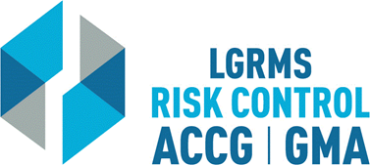
Check for Understanding
This document is used to verify that the employee attending the training (The Trainee),
understands the key points of the training provided.
Topic: |  |  | Workplace Harassment Training for Supervisors
Circle the best answer to the following questions
1. | Employers MUST maintain an effective electronics communication policy to include: texting, instant messaging, Facebook and Twitter.  True  False
2. | Is your work e-mail subject to Public Records/Open Records Act?  Yes  No
3. | Having a written policy in place is adequate and training on said policy is unnecessary.  Yes  No
4. | There is a seven-year retention requirement for training records.  True  False
5. | An employee will adhere strictly to the normal chain of command in reporting a harassment claim.  True  False
6. | Anonymous complaints do not require investigation.  True  False
7. | ALL complaints must be in writing or recorded to be considered valid.  True  False
Employer’s Name
City/ County:
Trainee Section – By signing this document, I verify that I have viewed the entire training video and completed the questions within “Check for Understanding” document without any outside assistance.
Print Trainee’s Name: |  |  |  |  | Date
Trainee’s Signature:
Employer’s Training/ Safety/ HR Coordinator Section – By signing this document, I verify that the “Trainee” has viewed the entire training video and completed the questions within “Check for Understanding” document without any outside assistance.
Print Coordinator’s Name: |  |  |  |  | Date
Coordinator’s Signature:
Please scan and return via e-mail to lgrmsadmin@lgrms.com or via mail to LGRMS, 3500 Parkway Lane, Suite 110, Norcross, GA, 30092

