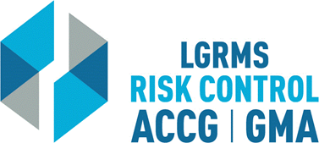
Check for Understanding
This document is used to verify that the employee attending the training (The Trainee),
understands the key points of the training provided.
Topic: |  |  | Slip, Trip, and Fall
Circle the best answer to the following questions
1. | What is the minimum height issue involved?  A. 1”  B. ¾”  C. ½”  D. ¼”
2. | Can the simple use of a cell phone while walking present a hazard?  Yes  No
3. | What is the single most important factor to prevent slip, trip, and fall?  A. Warning others of a hazard  B. Housekeeping  C. Closing open filing cabinets
4. | It is okay to come down a ladder with your back to the ladder, as long as you are holding on securely.  True  False
Employer’s Name
City/ County:
Trainee Section – By signing this document, I verify that I have viewed the entire training video and completed the questions within “Check for Understanding” document without any outside assistance.
Print Trainee’s Name: |  |  |  |  | Date
Trainee’s Signature:
Employer’s Training/ Safety/ HR Coordinator Section – By signing this document, I verify that the “Trainee” has viewed the entire training video and completed the questions within “Check for Understanding” document without any outside assistance.
Print Coordinator’s Name: |  |  |  |  | Date
Coordinator’s Signature:
Please scan and return via e-mail to lgrmsadmin@lgrms.com or via mail to LGRMS, 3500 Parkway Lane, Suite 110, Norcross, GA, 30092

