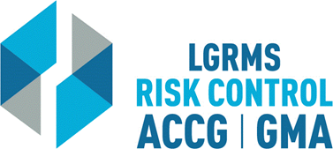
Check for Understanding
This document is used to verify that the employee attending the training (The Trainee),
understands the key points of the training provided.
Topic: |  |  | Eating Right for Health
Circle the best answer to the following questions
1. | Concerning Type II diabetes, there are 5.7 million undiagnosed people in the US today.  True  False
2. | For proper health and nutrition, it is heathier to change your dietary choices than it is to go on a diet.  True  False
3. | A healthy weight loss is one to two pounds a week.  True  False
4. | _____ is the key to healthy eating.  A. (Needs an answer to choose from)  B. (Needs an answer to choose from)
5. | Red meat is best consumed only _____.  A. Once a week  B. Once a month
6. | White bread/rice is a good source of carbohydrates.  True  False
7. | Our bodies need carbohydrates for fuel.  True  False
Employer’s Name
City/ County:
Trainee Section – By signing this document, I verify that I have viewed the entire training video and completed the questions within “Check for Understanding” document without any outside assistance.
Print Trainee’s Name: |  |  |  |  | Date
Trainee’s Signature:
Employer’s Training/ Safety/ HR Coordinator Section – By signing this document, I verify that the “Trainee” has viewed the entire training video and completed the questions within “Check for Understanding” document without any outside assistance.
Print Coordinator’s Name: |  |  |  |  | Date
Coordinator’s Signature:
Please scan and return via e-mail to ahowery@lgrms.com or via mail to LGRMS, 3500 Parkway Lane, Suite 110, Norcross, GA, 30092

