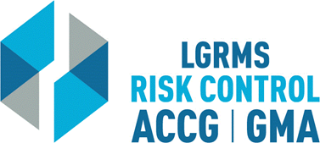
Check for Understanding
This document is used to verify that the employee attending the training (The Trainee),
understands the key points of the training provided.
Topic: |  |  | Community Oriented Policing
Circle the best answer to the following questions
1. | The community has to accept responsibility to help resolve the problem.  True  False
2. | Community trust and cooperation is part of the foundation of COPPS.  True  False
3. | Communication is paramount.  True  False
4. | COPPS is a reactive rather than proactive approach to resolving issues.  True  False
5. | Scanning is a process of determining where and when a problem is occurring and being repeated.  True  False
Employer’s Name
City/ County:
Trainee Section – By signing this document, I verify that I have viewed the entire training video and completed the questions within “Check for Understanding” document without any outside assistance.
Print Trainee’s Name: |  |  |  |  | Date
Trainee’s Signature:
Employer’s Training/ Safety/ HR Coordinator Section – By signing this document, I verify that the “Trainee” has viewed the entire training video and completed the questions within “Check for Understanding” document without any outside assistance.
Print Coordinator’s Name: |  |  |  |  | Date
Coordinator’s Signature:
Please scan and return via e-mail to lgrmsadmin@lgrms.com or via mail to LGRMS, 3500 Parkway Lane, Suite 110, Norcross, GA, 30092

