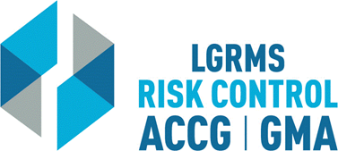
Check for Understanding
This document is used to verify that the employee attending the training (The Trainee),
understands the key points of the training provided.
Topic: |  |  | Ethics in Law Enforcement
Circle the best answer to the following questions
1. | What is NOT included as an example of Code of Ethics?  A. Constitution  B. Laws  C. Honor  D. All of the above
2. | Core values for LE: What does NOT belong?  A. Honor  B. Grace  C. Integrity  D. Respect  E. Courage
3. | Can our actions in our private lives have an effect on our professional integrity?  Yes  No
4. | A written Code of Ethics is NOT important for your department as long as there is an understanding of what is expected.  True  False
5. | Can accepting a free meal or reduced price be considered unethical behavior?  Yes  No
6. | Should a written policy in place reference the acceptance of gratuities?  Yes  No
7. | Documentation of training on Code of Ethics is NOT necessary as long as a written policy is in place.  True  False
Employer’s Name
City/ County:
Trainee Section – By signing this document, I verify that I have viewed the entire training video and completed the questions within “Check for Understanding” document without any outside assistance.
Print Trainee’s Name: |  |  |  |  | Date
Trainee’s Signature:
Employer’s Training/ Safety/ HR Coordinator Section – By signing this document, I verify that the “Trainee” has viewed the entire training video and completed the questions within “Check for Understanding” document without any outside assistance.
Print Coordinator’s Name: |  |  |  |  | Date
Coordinator’s Signature:
Please scan and return via e-mail to lgrmsadmin@lgrms.com or via mail to LGRMS, 3500 Parkway Lane, Suite 110, Norcross, GA, 30092

