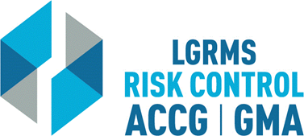
Check for Understanding
This document is used to verify that the employee attending the training (The Trainee),
understands the key points of the training provided.
Topic: |  |  | Vehicle Backing Course
Circle the best answer to the following questions
1. | According to the National Safety Council one out of every ___ accidents can be blamed on poor backing techniques.  A. 4  B. 6  C. 8
2. | The more of the side of your vehicle that is visible in your side view mirrors, the less apt you are to collide with an object while backing.  True  False
3. | Possible backing hazards include: inadequate clearance, objects behind your vehicle, and objects that move into the path of your vehicle.  True  False
4. | With the new technology of back up cameras and proper mirror adjustment, the need to exit the vehicle and check behind one’s vehicle is no longer important.  True  False
Employer’s Name
City/ County:
Trainee Section – By signing this document, I verify that I have viewed the entire training video and completed the questions within “Check for Understanding” document without any outside assistance.
Print Trainee’s Name: |  |  |  |  | Date
Trainee’s Signature:
Employer’s Training/ Safety/ HR Coordinator Section – By signing this document, I verify that the “Trainee” has viewed the entire training video and completed the questions within “Check for Understanding” document without any outside assistance.
Print Coordinator’s Name: |  |  |  |  | Date
Coordinator’s Signature:
Please scan and return via e-mail to ahowery@lgrms.com or via mail to LGRMS, 3500 Parkway Lane, Suite 110, Norcross, GA, 30092

